**IST 302 Case Study: Nittany Lion National Bank**

**Team Number 2**

**Team Name: Information Efficiency Group**

**Current Phase: Sprint 05**

Table of Contents

1 Project Overview 3

1.1 Executive Summary 3

1.2 Stakeholder Register 3

1.3 Stakeholder Management Strategy 3

2 Project Approval 4

2.1 Business Case 4

2.2 Charter 9

2.3 Assumptions 9

3 Project Scope 11

3.1 Scope Management Plan 11

3.2 Scope Statement 11

3.3 Requirements Management Plan 12

Requirements Traceability Matrix (RTM) 12

3.4 Work Breakdown Structure (WBS) 13

Work Breakdown Structure Dictionary 14

4 Project Schedule 15

4.1 Project Schedule Management Plan 15

5 Project Cost 16

Project Cost Management Plan 16

Activity Cost Estimates 17

6 Project Quality 19

Project Quality Management Plan 19

Change Request Form 20

Change Request Log 21

7 Project Resources 22

Project Human Resources Plan 22

Human Resource Loading 23

8 Project Risk 23

Risk Management Plan 23

Risk Register 25

Prioritized Risk List 25

9 Project Deliverables for the Client 25

9.1 Risk Assessment Tool 25

9.2 Strategic Risk Recommendations 28

10 Closing 29

10.1 Lesson Learned Report 29

10.2 Retrospective Presentation 32

Appendices 32

Appendix 1: Student Team Meeting Agendas and Reports 32

Appendix 2: Bibliography 45

Appendix 3: Student Team Roster 45

Appendix 4: Student Team Contract 45

# Project Overview

## Executive Summary

Our team is tasked with delivering a risk assessment tool that evaluates current and future IT risks, identifying high-risk areas, and presenting a strategic plan for risk mitigation. We will provide a detailed analysis of the bank's IT infrastructure, vendor relationships, and the potential impact of vendor failures on the bank's operations. The project aims to enhance NLNB's risk management capabilities, ensuring the security of client assets and the reliability of IT systems.

## Stakeholder Register

|  |  |  |  |  |
| --- | --- | --- | --- | --- |
| Name | Position | Internal/External | Project Role | Contact Information |
| Holly Johnson | Chief Executive Officer | Internal | Project Sponsor | holly@ninb.net |
| Connor Wayne | Chief Information Officer | Internal | Senior manager, PM’s boss | connor@ninb.net |
| Monica Wells | Chief Security Officer | Internal | Risk Management | monica@ninb.net |
| Stephen Lucas | Procurement Manager | Internal | Managing supplier relationships | stephon@ninb.net |
| Cynthia Hendrzak | Chief Risk Officer | Internal | Risk assessment | cynthia@nlnb.net |
| Anthony James | Software Development  Lead | Internal | Technical Skills | anthony@ninb.net |

## Stakeholder Management Strategy

|  |  |  |  |
| --- | --- | --- | --- |
| Name | Power/Interest | Current Engagement | Potential Management Strategies |
| Holly Johnson | High/High | Leading | Holly helped foster a new company objective relating to risk management. As a new hire she also introduced a new slogan “Building a sanctuary for your future”. Overall, Holly is very driven and a hard worker who emphasizes risk assessment and has a good relationship with the people in her department. |
| Connor Wayne | High/Low | Supportive | Connor is a great asset to the team. His role is crucial since he’s responsible for arranging bank employees and vendor representatives upon request. |
| Monica Wells | Low/High | Supportive | Due to the bank highlighting the importance of security, Monica’s job is crucial for the development of the project or any future tasks. |
| Stephen Lucas | Low/High | Neutral | Stephen’s job is critical for the flow in terms of the company’s supplies, but his tasks are more focused behind the scenes. |
| Cynthia Hendrzak | Medium/High | Neutral | Cynthia’s role more leans on the neutral side because she works behind the scenes and not directly with the team. |
| Anthony James | Medium/High | Neutral | Anthony is also an integral part of the team, but his role is needed more when there’s a specific task that needs to be taken care of. |

# Project Approval

## Business Case

|  |
| --- |
| **1.0 Introduction/Background**  The Nittany Lion national bank (NLNB) is in the northeastern region of the United States and provides their clients with intellect on investment, retail, and commercial banking. The NLNB was founded in 1911 by Darius and Derrick North in State College, PA, in which the company grew tremendously as they became a part of the S&P 500 Index and the Dow Jones Industrial Average. |
| **2.0 Business Objective**  NLNB aims to provide their clients with exceptional customer experience and satisfaction concerning the client's needs. With a new CEO (Holly Johnson) leading the company the new primary goal of NLNB is “Building a sanctuary for your future”. With this new chapter of NLNB they are also tackling risk assessments and safeguarding for future and current clients and investors. |
| **3.0 Current Situation and problem/opportunity statement**  Although NLNB wants to provide their clients and investors with a positive experience, reoccurring IT issues have made it difficult to successfully satisfy their needs. Here are two examples of past IT incidents:   * An upgrade in software caused the bank's system to freeze leading to a two-hour shortage (September 2022). * The NorthGo web application prevented clients from accessing their accounts. (December 2022).   Not only can these issues negatively affect the company but, it may affect NLNB’s credibility. These issues are also very costly to fix and the bank’s system freezing in September of 2022 incurred $100 million alone. However, these failures allow room for improvement. With my team's hard work and skillset, NLNB can enhance their IT infrastructure and better understand their current and past risks of the internal systems being used. |
| **4.0 Critical Assumptions and constraints**  The IT risk tool must make NLNB’s systems more efficient and be something of value for the company. Current employees and consultants must also approve of the tool to reduce risk. It should pay for itself within one year by aiding in project management and the status of company finances. With the reduction of risk, customer satisfaction and trust will increase, bringing in more revenue. The application must run on current systems and should require minimal technical support when in use. It must also be secure, only allowing users with accounts to access it. |
| **5.0 Analysis of options and recommendation**  There are three options for addressing this situation:  1. Do nothing. NLNB’s IT infrastructure may have risks, but the bank is successful so there is no need for enhancements.  2. Develop applications to eliminate unnecessary vendors.  3. Upgrade software and hardware within NLNB using an IT infrastructure tool and eliminate risk.  After analysis with our stakeholder, we have agreed that option 3 is the best course of action. |
| **6.0 Preliminary Project Requirements**  An effective project risk management tool must include the following:  1. Ability to provide resources regarding project risk management, such as templates. Users must be able to have guidance on how to use the tools, perhaps a video or written directions. Users must also be able to post their own helpful content, after moderation.  2. Ability to provide articles on assessing IT risk in businesses. Users should be able to search for these articles as well.  3. Ask an Expert feature, which builds and maintains relationships with the user, for more precise questions.  4. Ability to lay out all current projects in an organized, but simple way. It must be easy to read and interact with. Users must be able to see budgets, department of projects, and all information relating to proposed and current projects.  5. The entire application must have good security, where only users with credentials can gain access. Duo-Authentication must also be implemented.  6. The application must be compatible on all devices, such as Windows or Mac OS. |
| **7.0 Budget Estimate and Financial Analysis**  At the start of the project, NLNB will provide us with an initial payment of $10,000. This initial payment will be used for purchasing software, evaluating infrastructures, and obtaining services from suppliers. The final payment by NLNB will be made based on the hours worked multiplied by the hourly rates negotiated. This rate will be subtracted by the $10,000 pre-payment. |
| **8.0 Schedule Estimate**  The timeline for the project with NLNB will be taken place over three calendar months. The three-month timeline for this project is non-negotiable. During these three months, we will develop strategic recommendations that NLNB will focus on within the next 1-3 years. |
| **9.0 Potential Risks**  There are several risks that come along with this project. The technical risk is not finding an IT risk assessment tool that meets the requirements that NLNB is looking for. NLNB needs a tool that can be compatible with mac and windows OS and be easy for NLNB employees to use. The business risk of this involves obtaining the intellectual property rights of the tool and transferring them to NLNB. |
| **10.0 Exhibits**  Financial Life Cycle of the NLNB (According to budgeting of 10K)  The budget will be split into 1/3 of the total portion over the project's life cycle.. The $120,000 will only be the initial budget, but more money will be allocated to the project as seen fit. The benefits are assumed to gross $30,000 each month due to outstanding factors (government funding, common stock, stakeholders). The assumptions for work done will act as a separate entity from the exhibits for the sake of calculation purposes.  The allocation of funds for the work done on an hourly cycle throughout the process of the project is at a budget of $100,000. Since there are other resources that are present in the project’s arsenal, there should be leigh way for $20,000-$35,000 in the framework of for the NLNB that may not be included in future cost estimate graphs or tables. |

|  |  |  |  |  |  |
| --- | --- | --- | --- | --- | --- |
| Financial Analysis for Project Management | | | | | |
| Discount Rate | 8% |  |  |  |  |
| Assume the project will be done in 3 months |  | Year |  |  |  |
|  | **0** | **1** | **2** | **3** | **Total** |
| Costs | 120,000 | 30,000 | 30,000 | 30,000 |  |
| Discount Factor | 1 | 0.93 | 0.86 | 0.79 |  |
| Discounted Costs | 120,000 | 27,900 | 25,800 | 23,700 | 197400 |
| Benefits | 0 | 200,000 | 200,000 | 200,000 |  |
| Discount Factor | 1 | 0.93 | 0.86 | 0.79 |  |
| Discounted Benefits | 0 | 186,000 | 172,000 | 158,000 | 516,000 |
| Discounted Benefits-Costs | (120,000) | 144,720 | 130,720 | 116,720 |  |
| Cumulative Benefits-Costs | (120,000) | 144,720 | 261,440 | 350,160 | ← NPV |
| Payback in Year 1 | | | | | |
| Discounted Life Cycle ROI | 133.44% |  |  |  |  |
| Assumptions |  |  |  |  |  |
| Costs | # hours | Salary Total |  |  |  |
| PM (720 hours, $70/hour, 1 staff) | 5,040 | 50,400 |  |  |  |
| Staff (720 hours, $60/hour, 5 staff) | 4,320 | 216,000 |  |  |  |
| Outsourced Software and Services | 10,000 | 10,000 |  |  |  |
| Total Project Costs (all applied in year 0) | 120,000 | 197,800 |  |  |  |
| Benefits |  |  |  |  |  |
| Number of Consultants | 300 |  |  |  |  |
| Hours Saved | 40 |  |  |  |  |
| $/Hour Profit | 10 |  |  |  |  |
| Benefits From Saving Time | 120,000 |  |  |  |  |
| Benefits From 1% Increase in Profits | 30,000 |  |  |  |  |
| Total Annual Projected Benefits | 120,000 |  |  |  |  |

## Charter

|  |
| --- |
| **Project Title:** IT Risk Assessment Revamp **Project Start Date:** Jan 25th  **Projected Finish Date:** April 26th |
| **Budget Information:** The budget is $120,000. Most of the cost will be internal labor. Both Holly Johnson and Connor Wayne signed off on this. Additional resources will be included if the need arises. |
| **Project Manager:**  Rotational PM |
| **Project Objectives:**  Deliver a risk-assessment tool for NLNB that evaluates current and future IT risks, highlights risk areas, and determines risk mitigation plans. |
| **Main Project Successes Criterion:**  Project should pay for itself over a year post completion. |
| **Approach:**  Conduct interviews with key stakeholders such as IT and risk management to understand concerns and expectations for a risk assessment tool.  Investigate and identify current risk exposure areas by going through IT infrastructure  Research software to aid in risk management and in developing new assessment tools  Gather data through surveys, interviews, and statistics on risk management strategies for the tool to utilize in its own strategic planning  Determine value and efficiency of the tool both immediately after project completion and for the year afterwards. |

## Assumptions

**Assumptions for roles and positions in the team are provided below:**

|  |  |  |  |
| --- | --- | --- | --- |
| **Number** | **Name** | **Explanation** | **Impact if assumption is false** |
| 1 | **Project Sponsor long-run assumption** | Holly Johnson -With the given budget and allocation of funds for the project, the project should pay for itself in a year’s time. | If this assumption is false, then the Net Loss will affect the bank in a negative way, which will force the firm to start from behind in next year’s financing escapade. |
| 2 | **Work week Framework** | Connor Wayne - Both Johnson and Wayne signed off with the assumption that 80 hours a week will be allocated to the project for 12 weeks of the project's duration. | If outstanding factors affect this notion like perhaps a market collapse, the hours will vary due to the occurrence. Therefore, the payment to the staff and the acting PM will be affected as well. |
| 3 | **Risk Management Involvement** | Monica Wells - Risks will be litigated as quickly as they arrive, with the due diligence to resolve them before they become present. | With the project’s short timeline, any risks that aren’t accounted for will delay the project’s progress, which will be detrimental to the process. |
| 4 | **Managing Supplier Relationships** | Stephen Lucas - Supplier relationships will remain strong throughout the duration of the project process and any needs will be assessed and brough forward to the board. | If a key supplier were to withdraw from the project, the firm would be forced to move elsewhere to find compensation for the supplies needed. Worst case scenario will |
| 5 | **Risk Assessment for Project Management** | Cynthia Hendrzak - Assessment will be factored in and garnered in accordance with the project management plan. | If the plan is subject to change, the Risk Assessment must evolve with the changes made in the project life cycle if scope creep were to occur. |
| 6 | **Software Development** | Anthony James- Software Dev. Will be critical in the process for fine-tuning the Risk Assessment. Guidelines for the network processes must be considered. | If IT and Software development fail to do their job (Security and Data protection, cloud-sourcing important data to the organization) within the project scope, the whole objective is subject to fail. |
| 7 | **Project Management** | Project Management will be rotational if needed but Gabriel will handle it until otherwise needed. | If progress is stalling, Gabriel will be forced out of the position and a better competent individual will be the replacement |

# Project Scope

## Scope Management Plan

The scope management plan for the IT Risk Assessment Revamp project at Nittany Lion National Bank (NLNB) is designed to deliver a comprehensive risk assessment tool focused on evaluating current and future IT risks, identifying high-risk areas, and formulating a strategic risk mitigation plan. This initiative is crucial for enhancing NLNB's risk management capabilities to ensure the security of client assets and the reliability of IT systems. The project involves a detailed analysis of the bank's IT infrastructure, vendor relationships, and the potential impacts of vendor failures on operations, aiming to bolster NLNB’s stance on risk management under the new leadership of CEO Holly Johnson. The project garners support from internal stakeholders such as Connor Wayne, the CIO, Monica Wells, the CSO, and others, reflecting a strong internal backing for this initiative. The project's business case highlights NLNB's need to address recurring IT issues that have previously impacted customer satisfaction and credibility, emphasizing the importance of this project for the bank's operational efficiency and reputation. With a budget of $10,000 and a strict three-month timeline, the project aims to deliver a tool that not only addresses current IT risks but also positions NLNB to manage future challenges effectively. The project's success hinges on the collaborative effort of the project team and stakeholders, adherence to the budget and schedule, and the tool’s ability to enhance NLNB’s IT risk management practices, ultimately ensuring the project pays for itself within a year post-completion.

## Scope Statement

**Project Charter:**

Deliver a risk-assessment tool for NLNB that evaluates current and future IT risks, highlights risk areas, and determines risk mitigation plans.

**Project Scope Statement, Version 1:**

Servers: For the improvement of NLNB it's an optimized software upgrade. Since the first upgrade attempt failed, we must acknowledge possible bugs in the servers and analyze how the first attempt could have gone wrong and create a sustainable solution. The prime concern is establishing software that won’t affect the current one and cause issues such as a system freeze.

**Project Scope Statement, Version 2:**

Server’s: This project will require an influx of servers that can support the current database. This new implementation will ensure that there won’t be any failures that resulted from the last upgrade attempt. To hold ourselves accountable we’ll be implementing a risk assessment program. With this the bank can prioritize remediation action plans to manage its risks effectively.

## Requirements Management Plan

For the duration of the project, we plan to track our activities in several forms. Firstly, we plan to do so through the documentation of our weekly standups. This is where we track the progress of each team member and the tasks that were delegated to them for that sprint. The second way we plan to monitor our progress is through our Requirements Traceability Matrix, where we can track all the requirements needed to appease our stakeholders. This ensures we will exceed all expectations by the time our project ends. In addition, we created a schedule, with the help of MS Project, to visibly oversee all advancements and stay prepared for future tasks. It is also easily adaptable in preparation for any new tasks we may need to add to our plan.

Our prioritization of requirements depends on what specific tasks need to be completed per deliverable. The project is separated into several two-week sprints so that we can easily decide what to work on and when. Each task within each deliverable is on the same priority level, since all team members will have different focuses for that duration. We frequently continue to refer to our textbooks and the case overview to stay up to date on the specifics of which IT issues NLNB faces. We also are provided with a rubric for each sprint that gives us another guideline to verify that all required material is included. This rubric is one of our main references when facilitating our deliverables. Not to mention, we continue to receive feedback on our content, per sprint. After submission, we are provided with notes on how to improve our current work to gain maximum success. Due to the measures put in place, we can remain confident that all the requirements will be met with each submission.

## Requirements Traceability Matrix (RTM)

|  |  |  |  |  |  |
| --- | --- | --- | --- | --- | --- |
| Requirement Number | Name | Category | Source | Status | Description |
| R_01 | Budget Planning | Budget | Analyzing the financial statements and recording consumption and total costs. | Complete. | The recording of analyzing the financial statements is complete and our management plan will hold us accountable for any external factors. |
| R_02 | Technical Trial Run | Platforms (Window/Mac/Linux) | Ensuring Application are running on devices especially for MS project. | In progress. | Ran all applications and/or software successfully and completely. |
| R_03 | Develop Risk Assessment Plan | Security | Unveiling security issues and confirm applications are running without bugs. | Complete. | Security risks were not recorded but, precautionary measures were implemented |
| R_04 | Define Project Scope Statement | Scope | Ensuring the length and depth of this project and recording this analysis. | Complete. | The project boundaries have been set, and we are on track for a smooth progression in its duration. |
| R_05 | Define Project Schedule | Time/Schedule | Recording and detailing scheduling in the WBS for the project's duration. | In Progress. | After adjusting the project is on track to be finished by the deadlines sufficiently. Also upholding stakeholders are being accounted for in terms of needs. |

## Work Breakdown Structure (WBS)

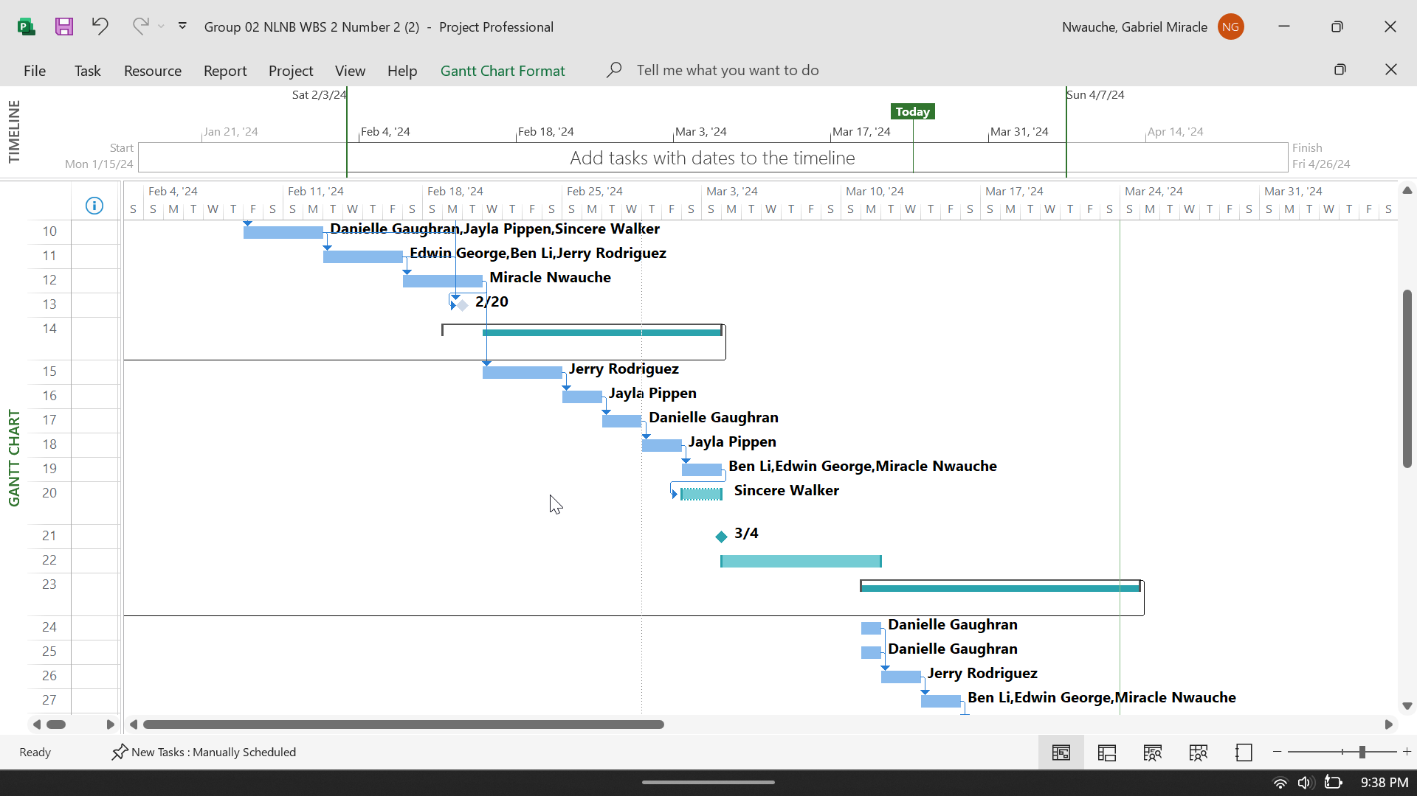

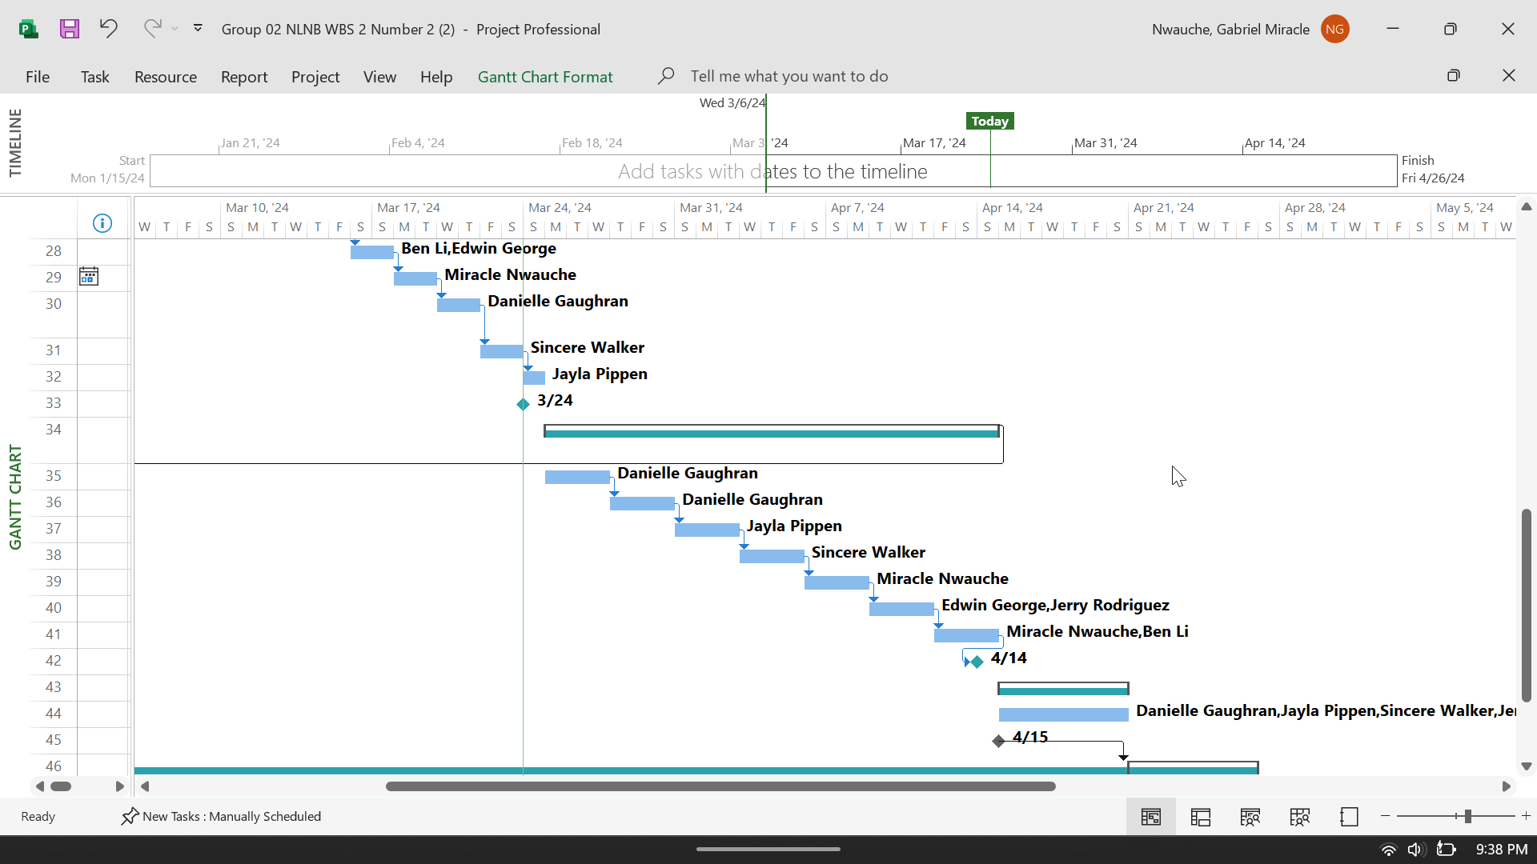

## Work Breakdown Structure Dictionary

**Item#**  **Item Name**   **Item Description**

1.1. Project Planning- For this project with NLB, extensive research went into formulating a strategy to begin this project. Thanks to using Microsoft one application, we can keep up to date with everything involving this project.

1.2. Project Execution- Executing the project so that it can be completed is a top priority. This is done by taking advantage of information provided by NLB and any information we learn about over this project.

1.3. Project Monitor- Monitoring the project is done thanks to the help of our team. By taking part in weekly standups, and having meetings throughout the week, we make sure that everyone has a task and that not one piece of the project is missing.

2.1. Software Specification- The software that NLB requires is a system that can safeguard not only the company itself but the data of the customers.

2.2. Software Development and Implementation - The software development for NLB will need to be tested to ensure that it meets our client's standards. NLB requests that the software itself is accessible with different OS, and that it is easy to understand from the perspective of the client.

2.3. Software Testing and Deployment- Testing the Software will see us finding different software that will aid in the risk mitigation for NLB. This means we will have to adhere to the specifications that NLB is looking for, and then once we have that software, we can begin deployment. The deployment of this software will happen once we discover that there are no issues with the software itself.

# Project Schedule

## Project Schedule Management Plan

The Project Schedule Management Plan for the IT Risk Assessment Revamp project at Nittany Lion National Bank (NLNB) is designed to ensure the timely and efficient completion of the project within a three-month timeframe. The plan outlines a strategic approach to scheduling, emphasizing the need for precise coordination and effective communication among project team members and stakeholders. It commences with the initiation phase, where the project's scope and objectives are defined, followed by a detailed planning phase where tasks are identified, sequenced, and assigned estimated durations. Key milestones include the completion of the IT infrastructure analysis, the evaluation of vendor relationships, and the development of the risk mitigation plan.

To manage and monitor the project's progress effectively, the plan incorporates regular status meetings and employs project management software tools for tracking tasks, dependencies, and deadlines. This proactive approach allows for the early identification of potential delays and the implementation of corrective actions to keep the project on track. The critical path method (CPM) is utilized to identify the sequence of pivotal tasks that directly impact the project's completion date, ensuring that these tasks receive priority attention and resources.

The plan also outlines a contingency strategy to address potential risks that could affect the schedule, such as unforeseen IT issues or delays in vendor responses. Flexibility is built into the schedule to accommodate minor setbacks without compromising the overall project deadline.

# Project Cost

## Project Cost Management Plan

**Level of Accuracy**

Financial Accuracy Determination: Our team uses detailed cost estimation methods, such as parametric estimating and bottom-up estimating, to ensure high accuracy in financial projections. For rounding cost amounts, we adopt a standard approach where costs up to $500 are rounded to the nearest ten, and costs above $500 are rounded to the nearest hundred, considering potential variances and including a contingency reserve of 10% to account for unforeseen expenses.

**Unit of Measure**

Quantifying and Tracking Project Costs: Labor costs are quantified in hours and converted into monetary values based on the hourly rates agreed upon with the project stakeholders. These metrics are integrated into the Work Breakdown Structure (WBS) by assigning specific labor cost estimates to each work package, allowing for a detailed tracking of costs against the project plan.

**Organizational Procedures Links**

Access to Cost Accounting and Budget Breakdown: Detailed project cost accounting and budget breakdowns are maintained in a centralized project management software, accessible to all team members and relevant stakeholders. This information is integrated within our project management documents through dynamic links that update real-time as project costs are incurred and tracked.

**Control Thresholds**

Threshold for Review or Adjustment: The team has set a control threshold of a 10% variance from the baseline budget for any work package. Exceeding this threshold triggers a review and potential adjustment in project spending, requiring approval from the project sponsor to ensure the project remains aligned with its financial objectives.

**Rules of Performance Measurement**

Tracking Costs and Measuring Performance: Our team employs the Earned Value Management (EVM) system to track project costs and measure performance. Key performance indicators such as Cost Performance Index (CPI) and Schedule Performance Index (SPI) assess the efficiency of resource and cost allocation, helping to identify trends and make informed decisions on budget management.

**Reporting Formats**

Compilation and Sharing of Cost Reports: Cost reports are compiled monthly and after major project milestones, using standardized templates that highlight budgeted versus actual costs, variances, and performance indexes. These reports are shared with stakeholders through email and project management platforms, ensuring clarity and accuracy in our financial tracking.

**Process Descriptions**

**Managing Costs Throughout the Project:**

Budgeting and Estimation: Establish an initial budget based on detailed cost estimations for all project activities.

Tracking and Monitoring: Regularly track actual project costs against the budget, using project management software for real-time monitoring.

Variance Analysis: Conduct variance analysis to identify discrepancies between planned and actual expenditures.

Review and Adjustment: Implement a review process for any variances exceeding the control thresholds, adjusting project plans and budgets as necessary.

Reporting: Provide regular cost performance reports to stakeholders, highlighting any concerns and adjustments made to ensure project alignment with its financial goals.

Closing: Conduct a final project audit to assess overall financial performance, capturing lessons learned for future projects.

## Activity Cost Estimates

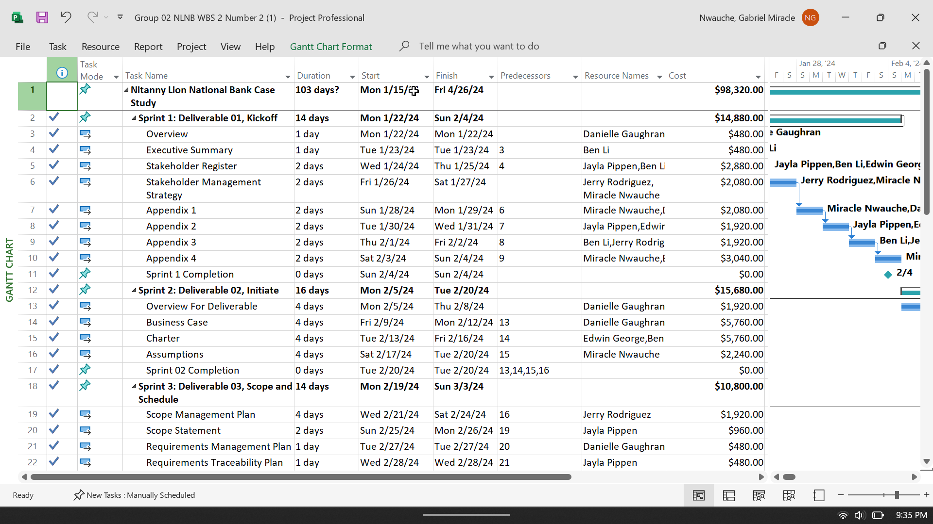

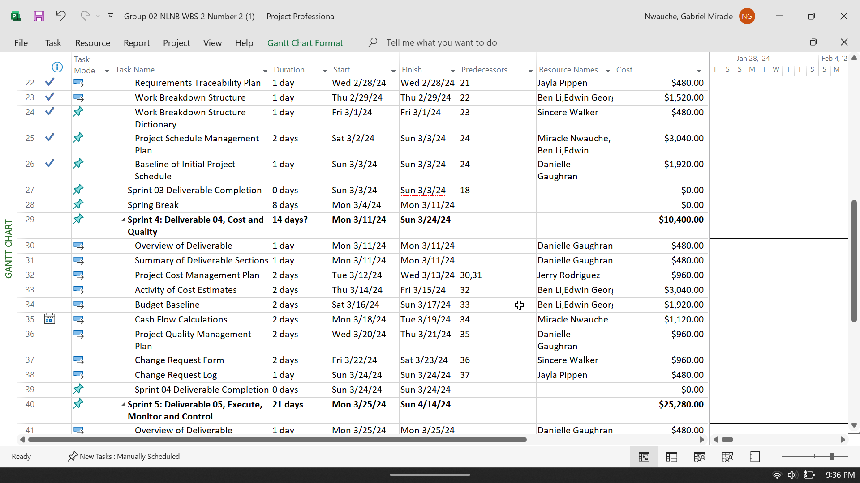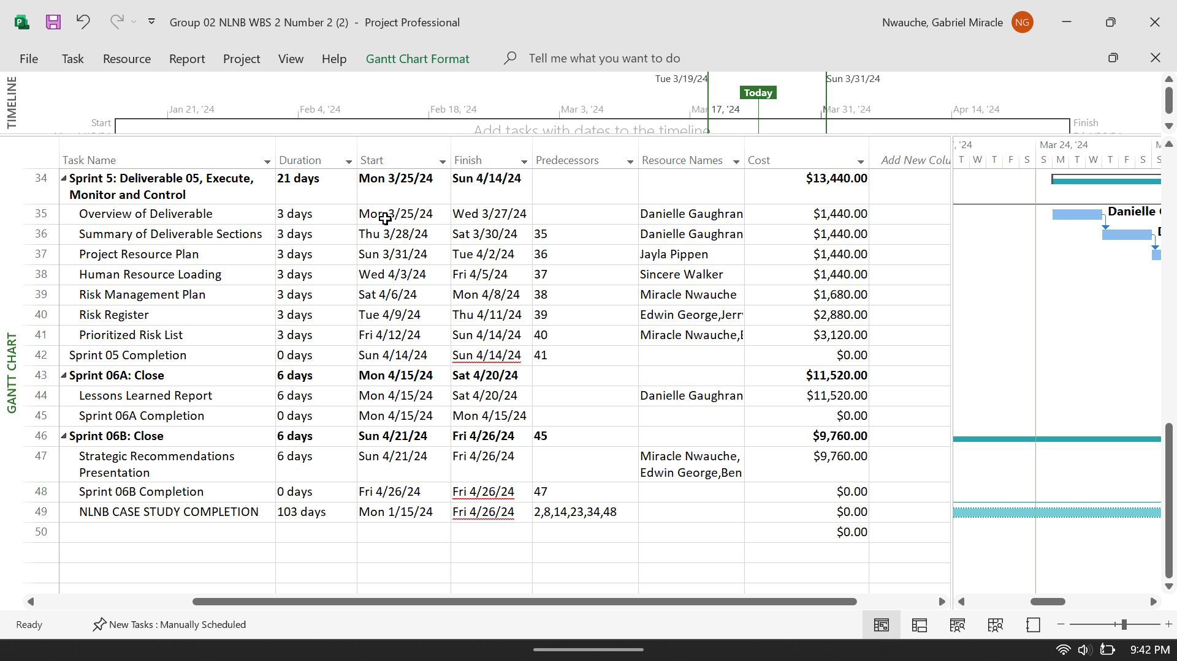

***Budget Baseline***

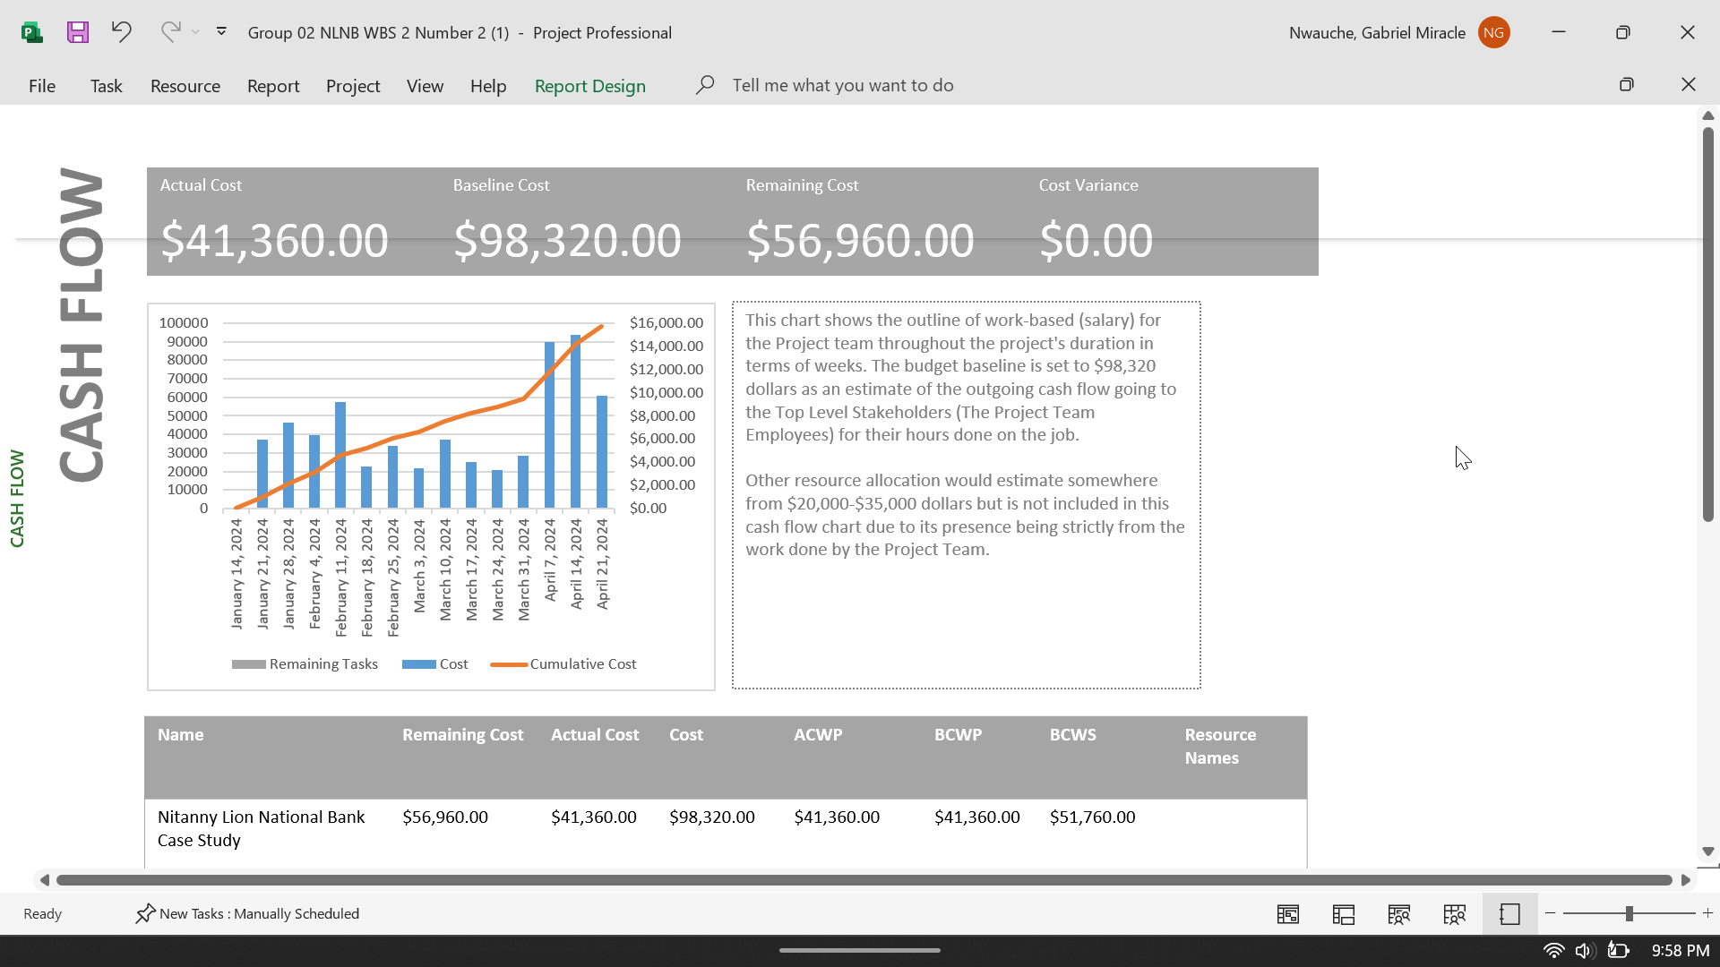

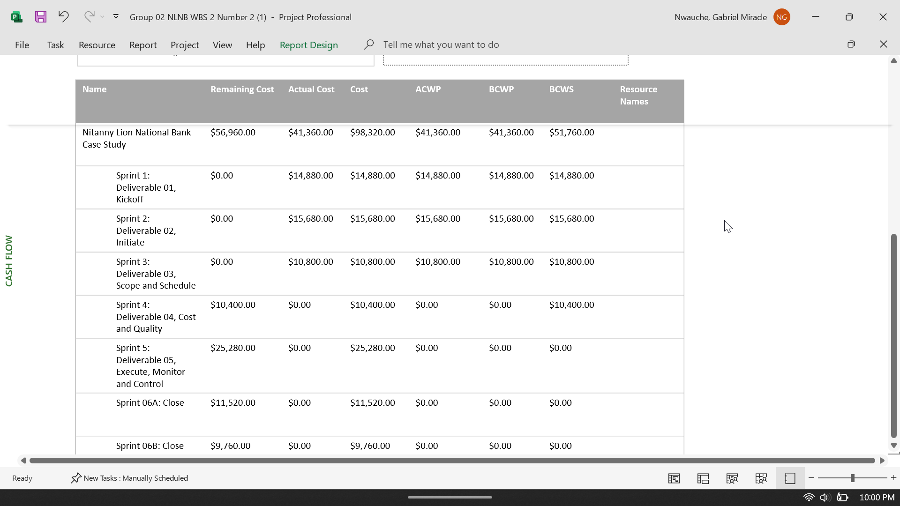

# Project Quality

## Project Quality Management Plan

To guarantee that the quality of our project aligns with our team’s goals, we have created guidelines to follow in our Project Quality Management Plan. This plan includes all the specific areas we will focus on to successfully complete this project.

**Functionality and Features**

Each deliverable will be assessed on its ability to provide needed material for NLNB’s IT infrastructure risks. With our Risk Assessment Tool, we plan to provide metrics on their current systems and applications at NLNB and how effective they are in NLNB’s day-to-day business functions. There should be regular audits and testing of the Risk Assessment Tool to ensure its functionality is consistent and efficient in relation to NLNB’s needs.

**Project Outputs**

The information provided from the Risk Assessment Tool must be easily understandable for any NLNB employee. It must also be well-documented, with continuous documentation tests to ensure readability. We will also continue to report on each task we complete and our plan for the project. We will include risks, schedules, documentation of our weekly standups, and any risks and impediments.

**Performance**

It is necessary for our Risk Assessment Tool to be accessible on different computers, whether Windows or Mac, without any issues. To properly use the tool, NLNB workers must be trained in all its functions. Once trained, employees must perform regular quality testing of the tool.

**Reliability**

Continuous testing of the Risk Assessment Tool will also provide proof of reliability for NLNB and it’s risk analysis provided for them. This will ensure that all data imported into the tool is accurate, and it’s analysis is accurate.

**Maintainability**

The Risk Assessment Tool must be able to be maintained once the Information Efficiency group concludes the project. Not only should regular updates be managed by NLNB employees, but there should be documentation of any changes made to the data in the tool. NLNB must also be responsible for continuous employee training of the tool, as changes to it are made to better suit NLNB’s business objectives.

## Change Request Form

|  |  |  |  |
| --- | --- | --- | --- |
| Project Name | IST 302 Case Study: Nittany Lion National Bank  Spring 2024 | | |
| Requested By | *Name of Request* | *Date* | |
| Request Number | *Request #* | *Name of Request* | |
| Change Description |  | | |
| Change Reason |  | | |
| Impact of Change |  | | |
| Proposed Action |  | | |
| Status | *In Review* | *Approved* | *Rejected* |
| Approval Date |  | | |
| Approved By |  | | |

## Change Request Log

|  |  |  |  |  |  |
| --- | --- | --- | --- | --- | --- |
| Request # | Description | Filed Date | Anticipated Impact | Status | Comment |
| 01 | Requests to make changes to the WBS Dictionary. | 2/19/24 | The WBS dictionary needs to be updated to ensure it's up to date with other recent modifications made to the project document. | Approved | These updates will ensure the WBS information in the project is cohesive and aligns with the dictionary. |
| 02 | Requests to add changes to the past sprints. | 3/14/24 | The past sprints will be slightly revised to include a more in-depth description. This will be beneficial for group members to have an accurate description of what took place. | In review |  |
| 03 | Requests to add a changes to the requirements traces remix (RTM) to ensure other parts won’t be affected. | 3/21/24 | Ultimately the information in the RTM is inaccurate and will be updated to align with the remaining documented information and stay on task with the progress of the deliverables. | Approved | Changes have been made to the RTM. With accurate updates in the remaining progression of the project will run seamlessly. |
| 04 | Requests to add a table breakdown of the schedule to have an in-depth breakdown of the schedule set up. | 3/19/24 | A table breakdown of the schedule with help understand the content containing the schedule. This will be a way of visualizing the schedule specifically. | In review |  |
| 05 | Requests to complete the project tasks in a timely manner. Also communicating any issues or concerns about the project or any external concerns. | 3/19/24 | Thorough communication will aid in the success of this project. Complete tasks promptly will also leave more time for questions/concerns to be answered before deliverable due date. | Approved | The tasks were completed, and the team has continued to communicate any other concerns. |

# Project Resources

## Project Human Resources Plan

**Collaborating Resource Management**

Planning resource management occurs at the beginning of the initial project. We Will manage the requirements laid out in our team charter such as the roles of each group member, our responsibilities, and our expectations to be followed moving through the project. Our resource management plan will be laid out using the supplies (hardware, software, members, monetary budgets, etc.) included in our required resources.

**Project Team**

Our project team has been working with NLNB since week one. Our team meets 1-2 times throughout class/outside and with our EY representative. We also share one drive folder that all members of our team have access to too, and where we can all work on the same project document at once. This is important to access one another’s work and give feedback. Our team's primary way of communication is via GroupMe.

**Managing Resources**

Our team is aware of the current physical resources used for this project. The purpose of this is to make sure that all our team members are performing to the highest standard for this project. The resources used will be recorded on the project document and MS Project. If any changes are made throughout the project, updates to the project are recorded on this project document and on MS Project. This allows our group to visualize the our physical resources and where we might need to make changes.

## Human Resource Loading

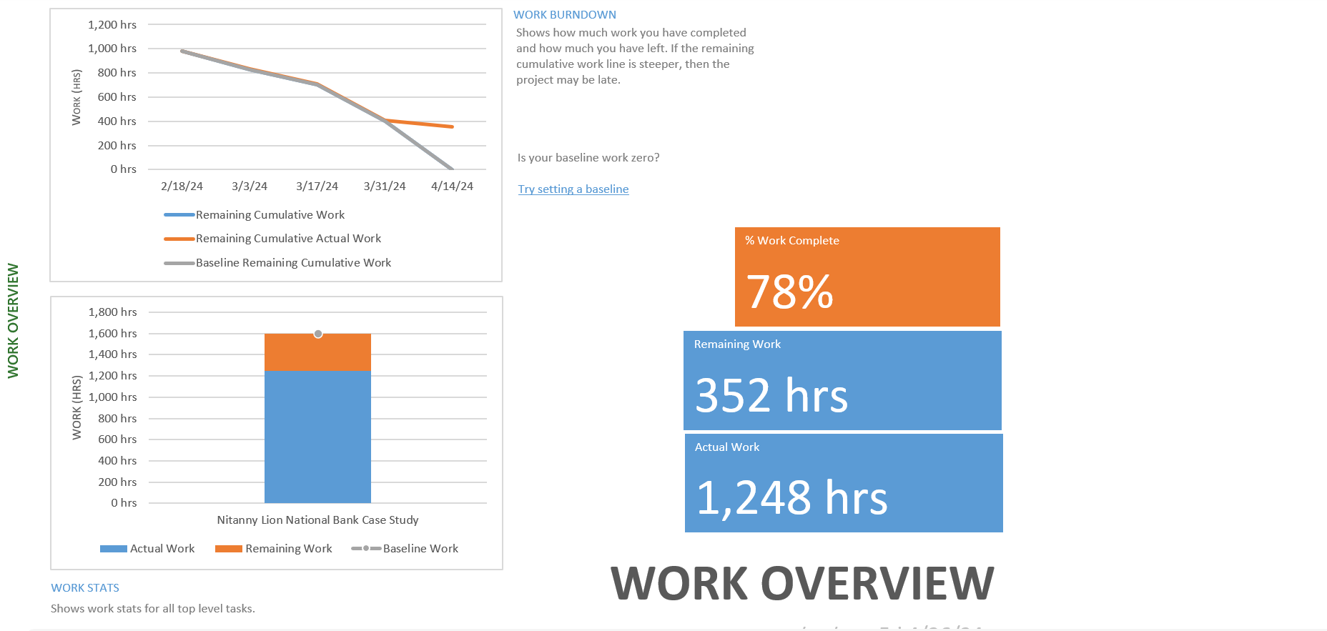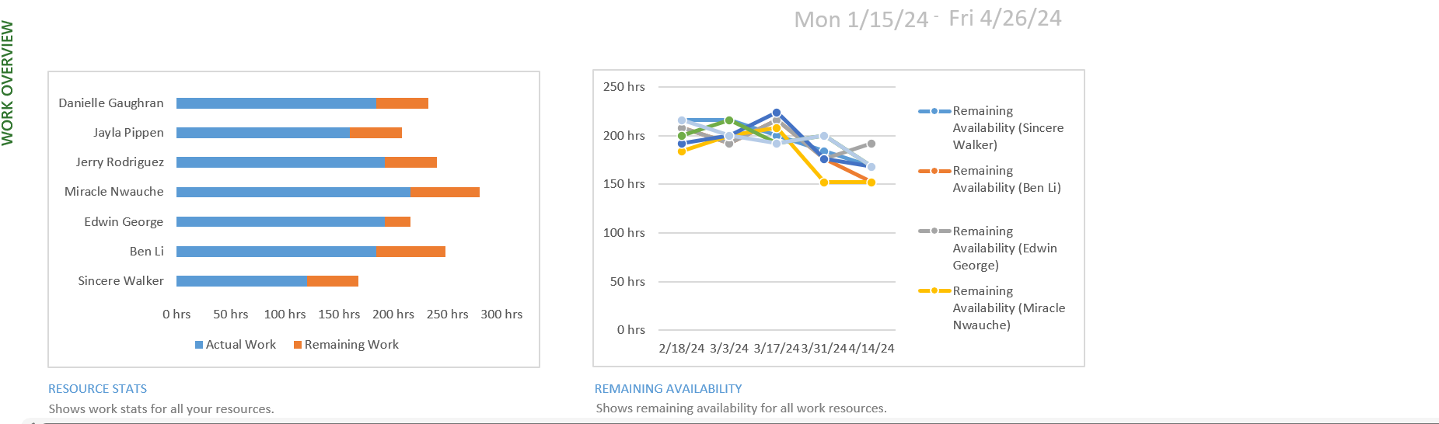

# Project Risk

## Risk Management Plan

**Methodology**

We will manage and mitigate all risks related to our project through our risk management strategy, which is compiled of a chain of steps. Our team first collectively produces different risks that could possibly affect our project. The risks identified are based on our past experiences in IT projects and expert opinions from our EY representative. The level of priority per risk is reliant on our gathered qualitative and quantitative data. This data will allow for a probability and impact score for each risk, which is then documented in our prioritized risk list. This way we are aware of the order we need to address each risk. In terms of mitigation, we will document each risk in our risk register, along with a resolution strategy. This will continue for the project’s entirety.

**Roles and Responsibilities**

The team members responsible for managing the risks of this project are the Project Manager and the Risk Manager. Their roles are to identify the possible risks of this project and to come up with mitigation strategies. They are also responsible for monitoring the successes and failures of those strategies. All members have a background in IT, so each member will contribute to the IT needs of each approach.

**Budget and Schedule**

To ensure effective risk management, it’s crucial to allocate specific budgetary resources and time to each identified risk category. This will include the costs associated with implementing mitigation strategies, monitoring risks, and any potential adjustments needed during the project lifecycle.

It is estimated that the risk-related advancements and activities will cost $7680. The first activity that will take place from 4/2/24-4/4/24 will be the Risk Management Plan, which will cost $1680. The second risk-related activity will take place from 4/5/24-4/7/24 will be the Risk Register, estimated to cost $2880. The third and final activity will be the Prioritized Risk List dating from 4/8/24-4/10/24 with a cost estimation of $3120.

**Risk Categories**

The major risk areas identified are Human Resources, Scope, Cost, Stakeholders, Scheduling and Communication.

**Risk Probability and Impact**

Our identified risks are assessed on the potential impact they may have on the project and the probability of it occurring. The qualitative measure of impact is analyzed and provided with a score of Insignificant, Minor, Moderate, Serious, or Major. The gathered quantitative data on the probability of these risk items occurring, will also be provided with a score of Insignificant, Minor, Moderate, Serious, or Major. If both the qualitative and quantitative scores for a risk are major, then that risk is considered major.

**Revised Stakeholder’s Tolerances**

The tolerances of the stakeholders have remained the same. If there were changes of their expectations, it would be recorded in the risk management plan, the risk register, and the prioritized risk list.

**Tracking**

The risk register is used to record all risk management actions taken by our team. This document is updated weekly. The Risk Manager is responsible for producing a lessons learned report that will be given to all stakeholders, as well as to the other members of the team. All team members are tasked with identifying potential new risks. If more assistance is needed with risk discernment, we will contact our EY representative.

**Risk Documentation**

We will document all identified risks and the processes in mitigating them in multiple forms. The different documentation types include a risk register, a lesson learned report, and a prioritized risk list.

## Risk Register

Click the link below to view the Risk Register Table:

[Risk Registr.xlsx](https://pennstateoffice365-my.sharepoint.com/:x:/g/personal/jnp5449_psu_edu/Ed1155Uc5KVFsG4RhO3sZ84B9S9WjCUE4NeNFdytxg8OWA?e=Ndsyhh)

## Prioritized Risk List

|  |  |  |  |  |
| --- | --- | --- | --- | --- |
| **Ranking** | **Potential Risk** | **Probability** | **Impact** | **Risk Score (Probability and Impact)** |
| **1** | Budget overrun | Serious (7) | Minor (3) | 3.5 |
| **2** | Team member left | Major (3) | Serious (10) | 7.5 |
| **3** | Scope creep | Serious (7) | Minor (3) | 5.25 |
| **4** | Communication Issues | Major (10) | Insignificant (2) | 5 |
| **5** | Dissatisfied Stakeholders | Major (10) | Minor (4) | 10 |
| **6** | Schedule Delays | Moderate (5) | Moderate (5) | 6.25 |
| **7** | IT Failure | Major (10) | Serious (7) | 20 |
| **8** | Loss of intellectual Property | Major (10) | Moderate (5) | 12.5 |
| **9** | Data Security | Major (9) | Serious (8) | 18 |
| **10** | Third Parties | Major (10) | Serious (8) | 20 |

# Project Deliverables for the Client

## Risk Assessment Tool

We have created a Risk Assessment Tool for NLNB that will allow for tracking of risks throughout their lifecycle. This tool will assist the bank in measuring and avoiding escalation of identified risks to their projects. It will provide quantitative and qualitative measures for both the probability of a risk occurring and the impact it may have. Both the impact score and the probability score are scaled from 1 to 10. A ranking of 1 to 2 means the risk is insignificant, 3 to 4 is minor, 5 to 6 is moderate, 7 to 8 is serious and 9 to 10 is considered major. Then an automatic risk score is calculated.

We have used our risk register to test our creation, inputting the possible risks of this project itself. The first step an NLNB user will take is to enter the supervisor's name, the team performing the test, and the date the test is taking place. The user is prompted to enter the risk that they are testing, from options given in a drop-down menu. These options include budget overrun, team member loss, scope creep, communication issues, dissatisfied stakeholders, schedule delays, IT failure, loss of intellectual property, and ‘other’ if their risk is unique to these choices. One chosen an automatic probability and impact score is given, and the average of the two are the provided risk score. Users will also receive a percentage and status update based off these parameters. The user is then prompted to manually categorize these risks, which allows for better organization. Once completed, NLNB will have the option to handle these risks by either avoiding, accepting, transferring, mitigating, or escalating them, based on what our tool outputs.

Each cell in the tool has a specific purpose, which is described below:

1. Supervisor – The supervisor administering the assessment
2. Team – The team performing the assessment
3. Date of the Assessment – The present day the assessment is being done
4. Risk Number – The number of the risk, used for organizational purposes
5. Description – A description of the risk being tested in the form of a drop-down menu (choices include Budget Overrun, Team Member Left, Scope Creep, Communication Issues, Dissatisfied Stakeholders, Schedule Delays, IT Failures, Loss of Intellectual Property, Data Security, Third Parties, Other)
6. Probability and Impact – Each are scaled from 1 to 10 (1-2 is Extremely Low, 3-4 is Low, 5-6 is Medium, 7-8 is High, 9-10 is Extremely High)
7. Risk – Score given to each risk, calculated by a combination of the probability and impact scores
8. Category – User uses the drop-down menu to manually categorize risks to keep better organization (choices include Cost, Human Resources, Scope, Communication, Stakeholder, Schedule, Technology, Security, or Other)
9. Status – Gives user a color of the status of the overall risk after calculations, based on the provided key below

Below we provided the steps a user should take to properly use the tool, alongside screenshots for reference:

**How to Use the Risk Assessment Tool**

**Step One:** User enters the Supervisor, team, and the date of the assessment.



**Step Two:** Using the drop-down selection for the Description category, the user then selects the option that best describes your risk. If there isn't a suitable option or the risk is unknown, the choice of ‘Other’ is provided for the user.

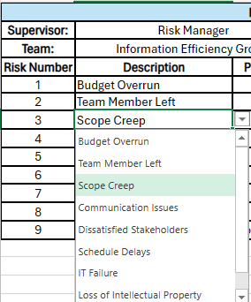

**Step Three:** Allow the tool to automatically calculate the risk score, based off the automatic probability and impact results determined off our 'Calculations' page**.**

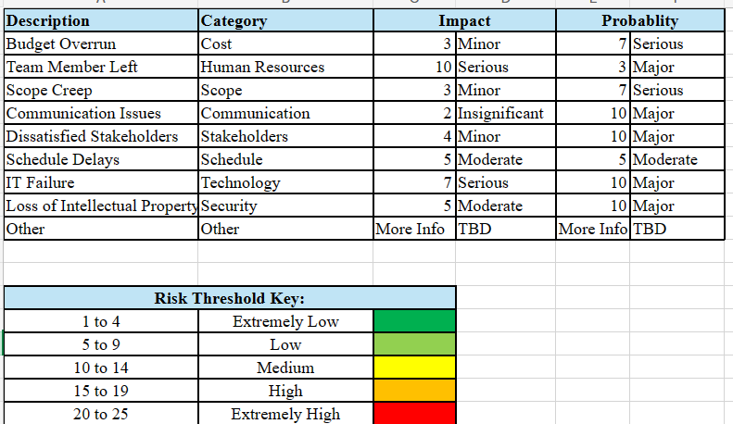

**Step Four:** User manually categorizes the risk as Cost, Human Resources, Scope, Communication, Stakeholder, Schedule, Technology, Security, or Other.

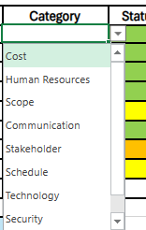

**Step Five:** Follow the five risk responses: Avoidance, Acceptance, Transference, Mitigation and Escalation based on the calculated risk score. *Your risk score and percentage are now calculated!*

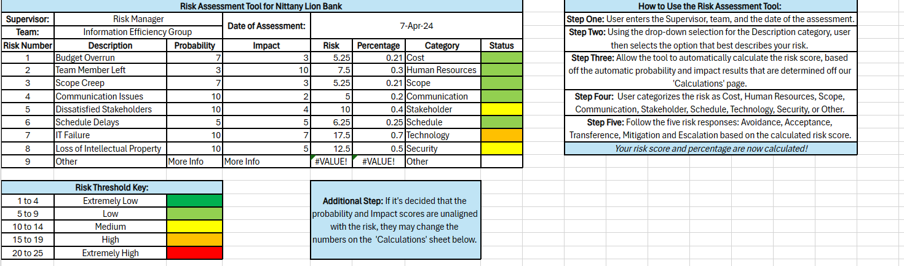

***Please Note\****

***Additional Step:*** *If it's decided that the Probability and Impact scores are unaligned with the associated risk, they may change the numbers on the 'Calculations' sheet below to make it better suited for their needs.*

## Strategic Risk Recommendations

Nittany Lion National Bank must consider a multitude of risks, each differing in severity. We have identified these main risks to be customer dissatisfaction, security breaches, IT failures, third-party vendor complications, systems failures, inadequate management of bank personnel and implementation issues relating to software and hardware. NLNB must undertake several crucial measures to address risks. The company should adhere to the following five fundamental responses:

Risk Avoidance: Remove the designated threat by addressing its underlying causes.

Risk Acceptance: Companies acknowledge and bear the consequences of risks they encounter.

Risk Transference: Transfer the consequences and management responsibility of a risk to a third party to minimize exposure.

Risk Mitigation: Minimize the impact of a risk by decreasing the likelihood of its occurrence.

Risk Escalation: When a risk exceeds the project manager's jurisdiction, it should be escalated to a higher-level manager for resolution.

These responses will allow NLNB to mitigate all possible risks. With help from our Risk Assessment Tool, each risk can be quantitatively measured of its possible impact and probability of occurrence. A combination of these measures produces a risk score, which gives the bank a clear indicator of how severe each risk is. This allows for the bank to easily choose a course of action in responding to each risk, whether it is risk avoidance, risk acceptance, risk transference, risk mitigation, or risk escalation.

Based on our criteria and the usage of our Risk Assessment Tool, we have identified and listed NLNB’s three main risks below:

1. Third Party Risk Management

- Conduct a comprehensive review of all third-party relationships, including vendors like PeoplePay and NorthGo, to assess their roles, responsibilities, and potential impact on NLNB's operations.

- Strengthen contract language to clearly define expectations, roles, and obligations of third parties, ensuring alignment with NLNB's risk management strategy.

- Implement a robust risk management process for third-party relationships, including regular monitoring and assessment of their performance and adherence to contractual agreements.

- Develop contingency plans to mitigate risks associated with third-party relationships, including protocols for terminating contracts if necessary, and realigning responsibilities to minimize exposure.

2. IT Failure Mitigation

- Establish proactive measures to address potential IT failures, including regular reviews and updates of hardware and software to align with NLNB's technology needs.

- Prioritize customer and stakeholder needs during IT failures by implementing short-term solutions to maintain essential services and minimize disruption.

- Develop and implement a new IT application, designed to meet NLNB's current and future technology requirements, while ensuring compatibility and security.

- Enhance security measures to mitigate risks associated with IT failures, including the escalation of security-related issues to appropriate teams based on established roles and responsibilities.

3. Data Security Risk Management

- Implement robust security protocols to safeguard sensitive information and prevent unauthorized access, including regular security audits and vulnerability assessments.

- Develop contingency plans to address potential security breaches, including protocols for responding to data breaches and restoring affected systems and data.

- Enhance employee training and awareness programs to promote adherence to security policies and practices, reducing the likelihood of security incidents.

- Collaborate with law enforcement and cybersecurity experts to investigate and mitigate the impact of security breaches, while ensuring compliance with regulatory requirements.

By implementing these strategic recommendations, NLNB can effectively manage and mitigate the risks associated with third-party relationships, IT failures, and security breaches, thereby enhancing the resilience and stability of its operations. Additionally, a proactive approach to risk management will enable NLNB to maintain trust and confidence among its customers, stakeholders, and regulatory authorities.

# Closing

## Lesson Learned Report

In retrospect of each deliverable the Information Efficiency Group has presented, we have come up with four questions to assess the effectiveness and efficiency of our work:

1. What aspects of this submission did we execute well?  
2. If given the chance to revise this section of the document, what changes would we make?  
3. How can we leverage this knowledge in future projects?  
4. What insights have we gainereg from this deliverable/task?

Deliverable 1:

* Overall, our first deliverable was done well. We based it off the textbook examples and we were only given minor suggestions on how to improve our sections.
* Changes we would make include deleting examples left in the book for the Stakeholder Register and the Stakeholder Management Strategy. This was something that our group continued to struggle with, even with the next two deliverables we had. Another change that would benefit our deliverable would be adding in a reference in our appendix 2.
* For future projects, we now know how to better communicate with one another to make sure that we are all on the same page. Examples were left in the document due to a lack of understanding of expectations between group members. We also will use what we learned in this deliverable to better identify stakeholders and create a strong foundation for beginning a project.
* This deliverable taught us how to write an executive summary, how to identify stakeholders and how to manage them, how to create team contracts and how to create meeting reports/agendas.

Deliverable 2:

* We successfully covered initial project activities such as the business case, project charter, and assumptions, setting a solid foundation for the project's documentation. It emphasized consistency and completeness, ensuring updates were made to previously submitted sections.
* Some changes we could make are to enhance the financial analysis section in the business case by providing more detailed projections and a robust risk assessment. This could offer a clearer view of potential financial outcomes and improve decision-making processes.
* For the future, we can have more frequent updates and revisions for projects, which enhances project flexibility and responsiveness.
* This deliverable collectively provided insights into the critical importance of thorough documentation and rigorous planning in setting a project up for success.

Deliverable 3:

* Overall, our third deliverable was done well. The third deliverable saw us creating a scope management plan that the NLNB will be able to use.
* Some changes we could make is to make sure that every piece of information in this deliverable is concise and so that everyone who reads these documents can understand it. Something else we struggled with was finding out the best way to break up the work of the MS Project.
* We can leverage this information in future projects by being better at dividing work amongst ourselves in the group.
* The biggest insight we have gained from this deliverable is learning how to divide work evenly throughout the group, and explaining more in depth the information that we write down.

Deliverable 4:

* Overall, our fourth deliverable was done well. We successfully invested effort into creating a comprehensive quality management plan and our Cost Management plan.
* Some changes we could make were to enhance our Change requests logs. Ensure that all change requests are thoroughly documented.
* For future projects, we gained insight into the importance of improving communication within teams to ensure common understanding. At several points in the document, examples are clearly included due to misunderstandings between group members, highlighting the need for clearer communication channels. Additionally, the insights gained from this result will inform your approach to identifying stakeholders and building a solid project foundation.
* This deliverable has offered significant insights into our project management procedures. "We have come to recognize the significance of efficient team communication in order to avoid misunderstandings and guarantee synchronization." The encounter has highlighted the significance of ongoing learning and development, prompting us to contemplate our actions and ascertain areas for refinement. Moreover, it has emphasized the importance of involving stakeholders and being adaptable in project management. In the future, we will utilize these insights to enhance our processes and attain improved results in upcoming projects.

Deliverable 5:

* In entirety, this deliverable was done very well despite some minor details that needed to be fixed. The resource management of the case was assessed in detail, which wasn’t touched on heavily in the other deliverables. Risk mitigation was finished with the Risk Assessment tool, which is important to have in our team’s arsenal.
* If given a chance to revise this section of the project and make changes, the Project Resource plan would have the following subsections added: “Estimating activity resources,” “Acquiring resources,” “Estimating activity resources,” and “Developing the project team.” With the addition of these subsections, the depth of the Resource Plan would have been covered. Another aspect that could have been revised is the alignment between the Prioritized Risks and the Risk Assessment tool. We would have added our other two top risks to our tool.
* We can use this information in this deliverable to have a better gauge of the remaining work schedule in the project’s life cycle and to better understand the risks that come with the project. With this knowledge, risks that may present themselves will be more visual before they appear.
* In theory, the more the project progresses, the more likely it is for risks to appear. If not expected and dealt with in a timely manner, the more destructive they could be to the project's success. The insights gained from this deliverable will be a good example for the importance of alignment in future projects.

## Retrospective Presentation

A link to our final presentation for NLNB’s senior management team:

[Strategic Recommendation Report](https://pennstateoffice365-my.sharepoint.com/:p:/g/personal/jnp5449_psu_edu/EXNga5GSjJVFtfQuyeA79j8B7CaxesJaUeqeLDdifOI3GA?e=h82EGW)

# Appendices

## Appendix 1: Student Team Meeting Agendas and Reports

**Kick-Off Meeting**

**01/23/2024**

**Project Name:** IST 302 Case Study: Nittany Lion National Bank

**Objective:** Introduce the project and review goals, constraints and tasks we need to accomplish for sprint 1.

**Agenda:**

* Introductions of each team member
* Decide upon most effective communication interface
* Review project parameters in case overview (scope, cost, time)
* Review textbook chapters in relation to current project goals
* Contact EY (Ernst & Young) representative to set up a zoom meeting
* Delegate tasks per team member
* Complete Appendix 3

|  |  |  |
| --- | --- | --- |
| Team Member | Assigned Tasks | Due Date |
| Danielle Gaughran | -Begin Appendix 1  -Complete Appendix 3  -Review textbook and Case Overview | 01/30/2024 |
| Jayla Pippen | -Begin Stakeholder Register  -Review textbook and Case Overview | 01/30/2024 |
| Miracle Nwauche | -Contact EY rep and set up a meeting  -Review textbook and Case Overview | 01/30/2024 |
| Edwin George | -Begin Stakeholder management Strategy  -Review textbook and Case Overview | 01/30/2024 |
| Benjamin Li | -Begin Team Contract  -Review textbook and Case Overview | 01/30/2024 |
| Jerry Rodriguez | -Begin Executive Summary  -Review textbook and Case Overview | 01/30/2024 |

1. What will you be working on until the next weekly standup?

Until our next weekly standup, we will be getting a better understanding of what the project requires. We will also work on the designated parts of deliverable 1 that we have divided amongst each other.   
2. Are there any impediments in your way?

The only impediment to our journey was the differing schedules that we have, which made it difficult to find a good time to meet with our EY representative.

**Weekly Stand-up**

**01/30/2024**

**Project Name:** IST 302 Case Study: Nittany Lion National Bank

**Objective:** Continue working independently on each assigned task we agreed upon. Meet with EY representative to analyze completed work and progression of project.

**Agenda:**

* Complete Appendix 1
* Complete Stakeholder Register
* Complete Stakeholder Management Strategy
* Complete Team Contract
* Complete Executive Summary
* Complete Bibliography
* Meet with EY representative

|  |  |  |
| --- | --- | --- |
| Team Member | Assigned Tasks | Due Date |
| Danielle Gaughran | -Complete Appendix 1 | 02/04/2024 |
| Jayla Pippen | -Complete Stakeholder Register | 02/04/2024 |
| Miracle Nwauche | -Help in parts needed and monitor progress | 02/04/2024 |
| Edwin George | -Complete Stakeholder Management Strategy | 02/04/2024 |
| Benjamin Li | -Complete Team Contract | 02/04/2024 |
| Jerry Rodriguez | -Complete Executive Summary | 02/04/2024 |

1. What did you accomplish since the last weekly standup?

Since the last weekly stand-up, we each began distinct aspects of our project. We set up a meeting with our EY representative to discuss our progress and decipher what we need to improve upon.  
2. What will you be working on until the next weekly standup?

Until the next weekly standup, we will continue to work on our first deliverable and have it completed by the due date this Sunday. We will also work on appendix 2 as whole, each adding any sources we use as we go along.   
3. Are there any impediments in your way?

There aren’t any impediments in our way at this point of the project.

**Weekly Stand-up**

**02/05/2024**

**Project Name:** IST 302 Case Study: Nittany Lion National Bank

**Objective:** Review Sprint 1 feedback. Familiarize ourselves with Sprint 2 and requirements for the deliverable 2 submission.

**Agenda:**

* Review textbook chapters in relation to current project goals
* Delegate needed tasks for deliverable 2 amongst members
* Contact EY representative to set up a meeting time for next week

|  |  |  |
| --- | --- | --- |
| Team Member | Assigned Tasks | Due Date |
| Danielle Gaughran | - Add to Appendix 1  - Read textbook chapters  - Work on Business case (parts 4-6) | 02/11/2024 |
| Jayla Pippen | - Read textbook chapters  - Work on Business case (parts 1-3) | 02/11/2024 |
| Miracle Nwauche | - Contact EY representative  - Read textbook chapters  - Work on Assumptions | 02/11/2024 |
| Edwin George | - Read textbook chapters  - Work on Project Charter | 02/11/2024 |
| Benjamin Li | - Read textbook chapters  - Work on Business Case (parts 7-9) | 02/11/2024 |
| Jerry Rodriguez | - Read textbook chapters  -Work on Project Charter | 02/11/2024 |

1. What did you accomplish since the last weekly standup?

Since our last weekly standup, we finalized our deliverable 1 and our submission was on time.   
2. What will you be working on until the next weekly standup?

We will be working on understanding the specifications of Sprint 2. We will refer to the textbook to properly execute our tasks and begin working on our individual assigned areas.   
3. Are there any impediments in your way?

There are no current impediments in our way.

**Weekly Stand-up**

**02/11/2024**

**Project Name:** IST 302 Case Study: Nittany Lion National Bank

**Objective:** Continue working independently on each assigned task we agreed upon. Meet with EY representative to analyze completed work and progression of project.

**Agenda:**

* Complete Business Case
* Complete Assumptions
* Complete Project Charter
* Meet with EY representative on our progress

|  |  |  |
| --- | --- | --- |
| Team Member | Assigned Tasks | Due Date |
| Danielle Gaughran | - Add to appendix 1  - Complete Business Case (parts 4-6) | 02/18/2024 |
| Jayla Pippen | -Complete Business Case (parts 1-3) | 02/18/2024 |
| Miracle Nwauche | -Complete Assumptions | 02/18/2024 |
| Edwin George | -Complete Project Charter | 02/18/2024 |
| Benjamin Li | -Complete Business Case (parts 7-9) | 02/18/2024 |
| Jerry Rodriguez | -Complete Project Charter | 02/18/2024 |
| Sincere Walker | -Complete Business Case (parts 7-9) | 02/18/2024 |

1. What did you accomplish since the last weekly standup?

We divided all parts of deliverable 2. We finished our textbook readings and began our tasks.  
2. What will you be working on until the next weekly standup?

We will continue to work on the business case, project charter and assumptions. It will be finalized by the submission due date, this Sunday. We also plan to meet with our EY representative for feedback on our status.   
3. Are there any impediments in your way?

Attendance was lacking due to illnesses.

**Weekly Stand-up**

**02/19/2024**

**Project Name:** IST 302 Case Study: Nittany Lion National Bank

**Objective:** Review Sprint 2 feedback. Familiarize ourselves with Sprint 3 and requirements for the deliverable 3 submission.

**Agenda:**

* Review Sprint 02 feedback and see how we can improve
* Review textbooks chapters that relate to new project requirements
* Delegate deliverable 3 tasks between members
* Contact EY representative to set up a meeting time for next week

|  |  |  |
| --- | --- | --- |
| Team Member | Assigned Tasks | Due Date |
| Danielle Gaughran | - Add to appendix 1  - Begin working on Requirements Management plan  - Read textbook chapters | 02/25/2024 |
| Jayla Pippen | - Begin working on Scope Statement and RTM  - Read textbook chapters | 02/25/2024 |
| Miracle Nwauche | - Begin working on Project Schedule Baseline  - Read textbook chapters | 02/25/2024 |
| Edwin George | - Begin working on Project Schedule Baseline  - Read textbook chapters | 02/25/2024 |
| Benjamin Li | - Begin working on Project Schedule Baseline  - Read textbook chapters | 02/25/2024 |
| Jerry Rodriguez | - Begin working on Scope Management plan and Project Schedule plan  - Read textbook chapters | 02/25/2024 |
| Sincere Walker | - Begin working on Work Breakdown Structure Dictionary  - Read textbook chapters | 02/25/2024 |

1. What did you accomplish since the last weekly standup?

Since our last weekly standup, we concluded our tasks for deliverable 02 and submitted it on time.   
2. What will you be working on until the next weekly standup?

Until the next weekly standup, we will acquaint ourselves with the new tasks needed for deliverable 03 and divide them equally amongst all group members. We will also read the textbook chapters pertaining to this sprint’s requirements.   
3. Are there any impediments in your way?

There are currently no impediments in our way.

**Weekly Stand-up**

**02/26/2024**

**Project Name:** IST 302 Case Study: Nittany Lion National Bank

**Objective:** Continue working independently on each assigned task we agreed upon. Meet with EY representative to analyze completed work and progression of project.

**Agenda:**

* Meet with EY representative on our progress
* Complete Requirements Management Plan
* Complete Scope Statement
* Complete Requirements Traceability Matrix (RTM)
* Complete Project Schedule Baseline
* Complete Scope Management plan
* Complete Work Breakdown Structure
* Complete Work Breakdown Structure Dictionary
* Complete Project Schedule plan

|  |  |  |
| --- | --- | --- |
| Team Member | Assigned Tasks | Due Date |
| Danielle Gaughran | - Add to appendix 1  - Complete Requirements Management Plan  - Make updates to previously submitted items | 03/03/2024 |
| Jayla Pippen | -Complete Scope Statement and RTM | 03/03/2024 |
| Miracle Nwauche | -Complete Project Schedule Baseline and Work Breakdown Structure | 03/03/2024 |
| Edwin George | -Complete Project Schedule Baseline and Work Breakdown Structure | 03/03/2024 |
| Benjamin Li | -Complete Project Schedule Baseline and Work Breakdown Structure | 03/03/2024 |
| Jerry Rodriguez | -Complete Scope Management plan and Project Schedule plan | 03/03/2024 |
| Sincere Walker | -Complete Work Breakdown Structure Dictionary | 03/03/2024 |

1. What did you accomplish since the last weekly standup?

We divided all parts of deliverable 3. We finished our textbook readings and began our tasks.  
2. What will you be working on until the next weekly standup?

We will continue to work on our specified duties for deliverable 03. It will be finalized by the submission due date, this Sunday. We also plan to meet with our EY representative for feedback on our status.   
3. Are there any impediments in your way?

Many of us are leaving for Spring break by Friday, so communication will be less effective by then. We plan to have it completed before Friday to avoid any confusion in our submission.

**Weekly Stand-up**

**03/11/2024**

**Project Name:** IST 302 Case Study: Nittany Lion National Bank

**Objective:** Review Sprint 3 feedback. Familiarize ourselves with Sprint 4 and requirements for the deliverable 4 submission.

**Agenda:**

* Review Sprint 03 feedback and see how we can improve
* Review textbooks chapters that relate to new project requirements
* Delegate deliverable 4 tasks between members
* Complete each individual task prior to next weekly standup
* Contact EY representative to set up a meeting time for next week
* Improve upon how we work together as group to produce better deliverables

|  |  |  |
| --- | --- | --- |
| Team Member | Assigned Tasks | Due Date |
| Danielle Gaughran | - Add to appendix 1  - Complete Project Quality Management Plan  - Make updates to previously submitted items  - Read textbook chapters | 03/18/2024 |
| Jayla Pippen | -Complete Change Request Log  - Read textbook chapters | 03/18/2024 |
| Miracle Nwauche | -Complete Budget Baseline and Activity Cost Estimates  - Read textbook chapters | 03/18/2024 |
| Edwin George | -Complete Budget Baseline and Activity Cost Estimates  - Read textbook chapters | 03/18/2024 |
| Benjamin Li | -Complete Budget Baseline and Activity Cost Estimates  - Read textbook chapters | 03/18/2024 |
| Jerry Rodriguez | -Complete Cost Management Plan  - Read textbook chapters | 03/18/2024 |
| Sincere Walker | -Complete Change Request Form  - Read textbook chapters | 03/18/2024 |

1. What did you accomplish since the last weekly standup?

Since the last weekly standup, we completed our third deliverable and handed it in on time.   
2. What will you be working on until the next weekly standup?

Until the next weekly standup, we plan to complete all our individual tasks and read the textbook chapters.   
3. Are there any impediments in your way?

Our group morale is low, as we did not receive a good grade on our last deliverable. However, we plan to take this as a lesson and improve on how we work as a unit moving forward.

**Weekly Stand-up**

**03/18/2024**

**Project Name:** IST 302 Case Study: Nittany Lion National Bank

**Objective:** Improve upon each task we agreed upon and ask questions for approval of changes. Meet with EY representative to analyze completed work and progression of project.

**Agenda:**

* Meet with EY representative on our progress
* Improve upon Project Quality Management Plan
* Improve upon Change Request Log
* Improve upon Budget Baseline
* Improve upon Cost Management Plan
* Improve upon Activity Cost Estimates
* Improve upon Change Request Form
* Improve upon prior submission and include needed material

|  |  |  |
| --- | --- | --- |
| Team Member | Assigned Tasks | Due Date |
| Danielle Gaughran | - Add to appendix 1  - Improve upon Project Quality Management Plan  - Make updates to previously submitted items | 03/24/2024 |
| Jayla Pippen | -Improve upon Change Request Log | 03/24/2024 |
| Miracle Nwauche | -Improve upon Budget Baseline and Activity Cost Estimates | 03/24/2024 |
| Edwin George | -Improve upon Budget Baseline and Activity Cost Estimates | 03/24/2024 |
| Benjamin Li | -Improve upon Budget Baseline and Activity Cost Estimates | 03/24/2024 |
| Jerry Rodriguez | -Improve upon Cost Management Plan | 03/24/2024 |
| Sincere Walker | -Improve upon Change Request Form | 03/24/2024 |

1. What did you accomplish since the last weekly standup?

We each completed the textbook readings and the tasks we delegated to the best of our ability.  
2. What will you be working on until the next weekly standup?

We will continue to work on perfecting our specified duties for deliverable 04. It will be finalized by the submission due date, this Sunday. We also plan to meet with our EY representative for feedback on our status.   
3. Are there any impediments in your way?

We also must improve our past submissions, so they are up to date with the level of quality we desire. For this reason, we have more work on our plate for this week.

**Weekly Stand-up**

**03/25/2024**

**Project Name:** IST 302 Case Study: Nittany Lion National Bank

**Objective:** Review Sprint 4 feedback. Familiarize ourselves with Sprint 5 and requirements for the deliverable 5 submission.

**Agenda:**

* Review Sprint 04 feedback and see how we can improve
* Review textbooks chapters that relate to new project requirements
* Delegate deliverable 5 tasks between members
* Complete each individual task prior to next weekly standup
* Contact EY representative to set up a meeting time for next week
* Improve upon how we work together as group to produce better deliverables

|  |  |  |
| --- | --- | --- |
| Team Member | Assigned Tasks | Due Date |
| Danielle Gaughran | - Add to Appendix 1  - Read textbook chapters  - Make updates to previously submitted items  - Begin Risk Assessment tool  - Begin Risk Management Plan | 04/01/2024 |
| Jayla Pippen | - Read textbook chapters  - Begin Risk Register  - Begin Prioritized Risk List | 04/01/2024 |
| Miracle Nwauche | - Read textbook chapters  - Begin Human Resource Loading | 04/01/2024 |
| Edwin George | - Read textbook chapters  - Begin Human Resource Loading  - Begin Risk Assessment tool | 04/01/2024 |
| Benjamin Li | - Read textbook chapters  - Begin Human Resource Loading | 04/01/2024 |
| Jerry Rodriguez | - Read textbook chapters  - Begin Strategic Risk Recommendations | 04/01/2024 |
| Sincere Walker | - Read textbook chapters  - Begin Project Resources Plan  - Begin Risk Assessment tool | 04/01/2024 |

1. What did you accomplish since the last weekly standup?

Since the last weekly standup, we completed our fourth deliverable and handed it in on time.  
2. What will you be working on until the next weekly standup?

Until the next weekly standup, we plan to begin all our individual tasks and read the textbook chapters.  
3. Are there any impediments in your way?

Currently, there are no impediments in our way.

**Weekly Stand-up**

**04/01/2024**

**Project Name:** IST 302 Case Study: Nittany Lion National Bank

**Objective:** Improve upon each task we agreed upon and ask questions for approval of changes. Meet with EY representative to analyze completed work and progression of project.

**Agenda:**

* Meet with EY representative on our progress
* Complete Risk Assessment tool
* Complete Risk Management Plan
* Complete Risk Register
* Complete Prioritized Risk List
* Complete Human Resource Loading
* Complete Strategic Risk Recommendations
* Complete Project Resources Plan
* Continue making updates to previously submitted items

|  |  |  |
| --- | --- | --- |
| Team Member | Assigned Tasks | Due Date |
| Danielle Gaughran | - Complete Risk Assessment tool  - Complete Risk Management Plan  - Continue making updates to previously submitted items | 04/08/2024 |
| Jayla Pippen | - Complete Risk Register  - Complete Prioritized Risk List | 04/08/2024 |
| Miracle Nwauche | - Complete Human Resource Loading | 04/08/2024 |
| Edwin George | - Complete Risk Assessment tool  - Complete Human Resource Loading | 04/08/2024 |
| Benjamin Li | - Complete Human Resource Loading | 04/08/2024 |
| Jerry Rodriguez | - Complete Strategic Risk Recommendations | 04/08/2024 |
| Sincere Walker | - Complete Risk Assessment tool  - Complete Project Resources Plan | 04/08/2024 |

1. What did you accomplish since the last weekly standup?

Since the last weekly standup, we delegated our tasks and read the textbook chapters in relation to what is required of us. We each got familiar with the expectations of deliverable 5.

2. What will you be working on until the next weekly standup?

We will each complete our assigned tasks and meet with our EY representative for some feedback.

3. Are there any impediments in your way?

There are currently no impediments in our way.

**Weekly Stand-up**

**04/08/2024**

**Project Name:** IST 302 Case Study: Nittany Lion National Bank

**Objective:** Improve upon each task we agreed upon and ask questions for approval of changes. Meet with EY representative to analyze completed work and progression of project.

**Agenda:**

* Meet with EY representative on our progress
* Improve upon and finalize Risk Assessment tool
* Improve upon and finalize Risk Management Plan
* Finalize updates to previously submitted items
* Improve upon and finalize Risk Register
* Improve upon and finalize Prioritized Risk List
* Improve upon and finalize Human Resource Loading
* Improve upon and finalize Strategic Risk Recommendations
* Improve upon and finalize Project Resources Plan

|  |  |  |
| --- | --- | --- |
| Team Member | Assigned Tasks | Due Date |
| Danielle Gaughran | - Improve upon and finalize Risk Assessment tool  - Improve upon and finalize Risk Management Plan  - Finalize updates to previously submitted items  - Finalize appendix 1 | 04/14/2024 |
| Jayla Pippen | -Improve upon and finalize Risk Register and Prioritized Risk List | 04/14/2024 |
| Miracle Nwauche | -Improve upon and finalize Human Resource Loading | 04/14/2024 |
| Edwin George | -Improve upon and finalize Human Resource Loading and Risk Assessment Tool | 04/14/2024 |
| Benjamin Li | -Improve upon and finalize Human Resource Loading | 04/14/2024 |
| Jerry Rodriguez | -Improve upon and finalize Strategic Risk Recommendations | 04/14/2024 |
| Sincere Walker | -Improve upon and finalize Risk Assessment Tool and Project Resources Plan | 04/14/2024 |

1. What did you accomplish since the last weekly standup?

Since the last weekly standup, we completed our delegated tasks to the best of our ability. We also met with our EY representative to discuss possible improvements on our work.   
2. What will you be working on until the next weekly standup?

Until the next standup we will finalize our tasks based on the feedback we received from our EY representative and submit our deliverable 5 in on time.   
3. Are there any impediments in your way?

Currently there are no impediments in our way.

**Weekly Stand-up**

**04/15/2024**

**Project Name:** IST 302 Case Study: Nittany Lion National Bank

**Objective:** Review Sprint 5 feedback. Familiarize ourselves with Sprint 6A and Sprint 6B and requirements for the deliverable submission.

**Agenda:**

* Review Sprint 05 feedback and see how we can improve
* Review textbooks chapters that relate to new project requirements
* Delegate deliverable 6A and 6B tasks between members
* Complete each individual task prior to next weekly standup
* Contact EY representative to set up a meeting time for next week
* Improve upon how we work together as group to produce better deliverables

|  |  |  |
| --- | --- | --- |
| Team Member | Assigned Tasks | Due Date |
| Danielle Gaughran | - Add to Appendix 1  - Read textbook chapters  - Work on Lessons Learned Report  - Make updates to previously submitted items | 04/23/2024 |
| Jayla Pippen | - Read textbook chapters  - Work on Presentation | 04/23/2024 |
| Miracle Nwauche | - Read textbook chapters  - Work on Presentation | 04/23/2024 |
| Edwin George | - Read textbook chapters  - Work on Lessons Learned Report | 04/23/2024 |
| Benjamin Li | - Read textbook chapters  - Work on Presentation | 04/23/2024 |
| Jerry Rodriguez | - Read textbook chapters  - Work on Presentation | 04/23/2024 |
| Sincere Walker | - Read textbook chapters  - Work on Lessons Learned Report | 04/23/2024 |

1. What did you accomplish since the last weekly standup?

Since the last weekly standup, we successfully completed and turned in our deliverable 5 on time.   
2. What will you be working on until the end of the course?

This is our last weekly standup, so we will continue to work on our independent tasks and finish the project strong. We will also present our findings to NLNB senior management.   
3. Are there any impediments in your way?

Currently there are no impediments in our way.

## Appendix 2: Bibliography

Schwalbe, K. (2021). *Information technology project management* (9th ed.). Cengage Learning

## Appendix 3: Student Team Roster

|  |  |  |
| --- | --- | --- |
| Name | Role / Expertise | Contact Information |
| Danielle Gaughran | Team Member | Email: [djg61884@psu.edu](mailto:djg61884@psu.edu)  Phone: 848-223-5104 |
| Edwin George | Team Member | Email: [ekg5332@psu.edu](mailto:ekg5332@psu.edu)  Phone: 201-665-6058 |
| Benjamin Li | Team Member | Email: [Bfl5322@psu.edu](mailto:Bfl5322@psu.edu)  Phone: 814-280-5321 |
| Jayla Pippen | Team Member | Email: [jnp5449@psu.edu](mailto:jnp5449@psu.edu)  Phone: 904-535-2013 |
| Jerry Rodriguez | Team Member | Email: [jfr5882@psu.edu](mailto:jfr5882@psu.edu)  Phone: 908-451-6565 |
| Miracle Nwauche | Team Leader | Email: gmn5192@psu.edu  Phone:9803071281 |
| Sincere Walker | Team Member | Email: Saw6219@psu.edu  Phone:215-279-1060 |

## Appendix 4: Student Team Contract

|  |  |  |
| --- | --- | --- |
| Member Name (Print) | Contact Information | Member Signature  Acknowledging Compliance |
| Benjamin Li | Email: Bfl5322@psu.edu  Phone: 814-280-5321 | Benjamin Li |
| Danielle Gaughran | Email: djg6184@psu.edu  Phone: 848-223-5104 | Danielle Gaughran |
| Jerry Rodriguez | [Email:jfr5882@psu.eduPhone](mailto:Email:jfr5882@psu.eduphone): 908-451-6565 | Jerry Rodriguez |
| Edwin George | Email: [ekg5332@psu.edu](mailto:ekg5332@psu.edu)  Phone: 201-665-6058 | Edwin George |
| Miracle Nwauche | Gmn5192@psu.edu | Miracle Nwauche |
| Jayla Pippen | Jnp5449@psu.edu | Jayla Pippen |
| Sincere Walker | [Saw6219@psu.edu](mailto:Saw6219@psu.edu)  215-279-1060 | Sincere Walker |

Code and Conduct

**Communication**

Weekly Updates: Communicate at least once a week through GroupMe to keep everyone informed.

Meeting Participation: Actively participate in all scheduled meetings.

Advance Notice: Notify the team in advance if they are not able to attend a meeting or meet a deadline.

Respectful Dialogue: Maintain a respectful tone in all forms of communication.

**Participation and Work Distribution**

Equal Effort: Contribute equitably to the project, ensuring timely and quality output.

Conflict Resolution: Address conflicts within the team.

Regular Check-Ins: Check communication channels daily and promptly respond to team communications.

**Division of Work**

Equitable Allocation: Distribute tasks fairly among team members.

Deadline Adherence: Set and respect deadlines for task completion and document reviews.

Quality Assurance: Regularly review and provide constructive feedback on each other's work.

Communication Methods

Preferred Channels: Agree on primary communication methods (e.g., email, Zoom, MS Teams).

Document Sharing: Utilize shared platforms like OneDrive for efficient document exchange.